

C5g Strong and Weak Acids
irritant !
corrosive !

What precautions should you take when working with acids?

Acid names | Formulae | Concentration  mol/dm³ | Colour of universal indicator | pH | Strong or Weak acid?
Hydrochloric acid | HCl | 1.0
Sulfuric acid | H₂SO₄ | 1.0
Nitric acid | HNO₃ | 1.0
Ethanoic acid | CH₃COOH | 1.0

Conclusions
- ethanoic acid is a ____________ acid
- hydrochloric, nitric and sulfuric acids are _____________ acids
- strong acids have a _________ pH than weak acids of the same concentration

Why are some acids stronger than others?
  - Acids are chemicals that ___________( dissociate) in water to produces ___ ions
  - An acid is strong if it ____________ ionises in water (100% of molecules ionise):
100%
Higher
LEARN
e.g.

- Weak acids only __________ ionise in water note that there is an __________
less than
1%
Higher
LEARN
e.g.
- You can see from the previous equation that the ionisation of a weak acid is an example of a _________________ reaction and produces an equilibrium mixture

- ______ is a measurement of the number of moles of hydrogen ions, H⁺ in solution
the _________ the hydrogen ion concentration, the __________ the pH number

- So, the pH of a weak acid is much ______________ than the pH of a strong acid of the _______________ concentration.

Higher Only
You must be able to explain the difference between acid strength and acid concentration:
CONCENTRATION: the concentration of an acid is a measure of

STRENGTH: How strong or weak an acid is i.e. its strength, is a measure of

strong =
weak =

Comparing the Reactions of Strong and Weak Acids

Both Strong and weak acids will perform these reactions:

metal + acid salt + hydrogen

metal oxide + acid salt + water

metal hydroxide + acid salt + water

Metal carbonate + acid salt + water + carbon dioxide

Experiment 1 – Compare the reaction of magnesium with HCl and CH₃COOH (ethanoic acid)

Observations
- The magnesium fizzes ________________________ with HCl
- The magnesium disappears ____________________ with HCl
- The test tube with HCl gets _______________ (more exothermic)
- Gas makes a _________________ with a lighted splint

Conclusion
  - Both ethanoic acid and hydrochloric acid react with magnesium to give ________

  - Ethanoic acid reacts _________________ than hydrochloric acid because there are fewer __________________ (H⁺). Fewer H⁺ means fewer ______________ with Mg so the rate of reaction will be ______________________.
Experiment 2 – Compare the reaction of calcium carbonate, CaCO₃ with HCl and CH₃COOH (ethanoic acid)

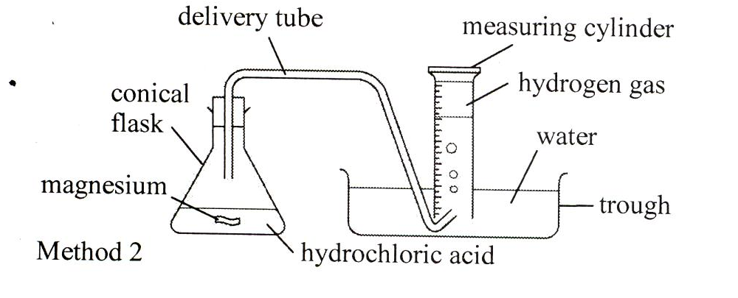

Calcium carbonate

Rate = 1
time

Results
Acid 1.0 mol/dm³ | Time to collect 10cm³ of gas (s) | Rate (s⁻¹)
Hydrochloric Acid HCl
Ethanoic acid CH₃COOH

TOTAL volume produced by both gases = 24cm³

Conclusions
- Both ethanoic acid and hydrochloric acid react with calcium carbonate to give _______________________.

2HCl + CaCO₃ CaCl₂ + CO₂ + H₂O

- Magnesium and calcium carbonate react slower with ethanoic acid than with hydrochloric acid of the same __________________________.

Explanation: the weak acid, CH₃COOH ionises less so fewer H⁺ means that there are fewer collisions with CaCO₃ which results in a slower rate of reaction
Summary (HIGH LEVEL)
Strong acid means almost _____% ionisation therefore there is a greater _______________ of hydrogen ions, H⁺. This leads to a greater _______________ frequency between reactant molecules and H⁺ so the rate of reaction is faster.

IMPORTANT
If the ____________ mass of solid is used and the ___________ volume and concentration of acid, then the _____________ total volume of gas is produced in experiment 1 and 2 but the weak acid produces it more _______________ than the strong acid.

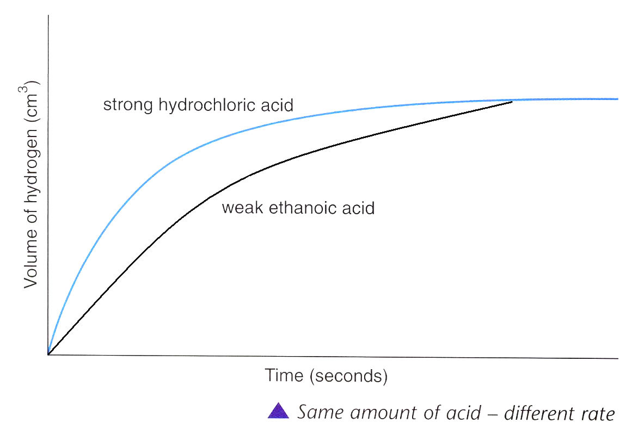

So, the volume of gas produced depends on the _________________ of acid and NOT on the strength.

Comparing the electrical conductivity of strong and weak acids
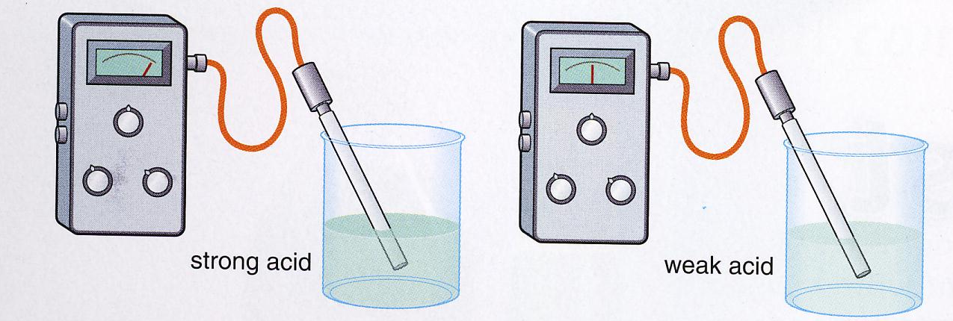

Results
Acid 1.0 mol/dm³ | Electrical conductivity
Hydrochloric Acid HCl
Ethanoic acid CH₃COOH

Conclusion
- ethanoic acid has a ____________ electrical conductivity than hydrochloric acid of the same concentration
Why?

- electrolysis of both ethanoic acid and hydrochloric acid makes hydrogen at the negative electrode
Why?
reduction
+

Higher Only
Ethanoic acid is ______ conductive than hydrochloric acid of the same concentration
because:
- ethanoic acid is __________ and hydrochloric acid is ___________
- HCl has a _____________ concentration of hydrogen ions to carry the charge
Weak acids can be really useful
One use for weak acids is as descalers – removing limestone from metal surfaces e.g. sinks and washing machines

Weak acids can be more useful than dilute strong acids

Higher Only
You must also be able to explain why a weak acid may be more useful than the more dilute strong acid but you must refer to the “hydrogen ion concentration” in your answer.

